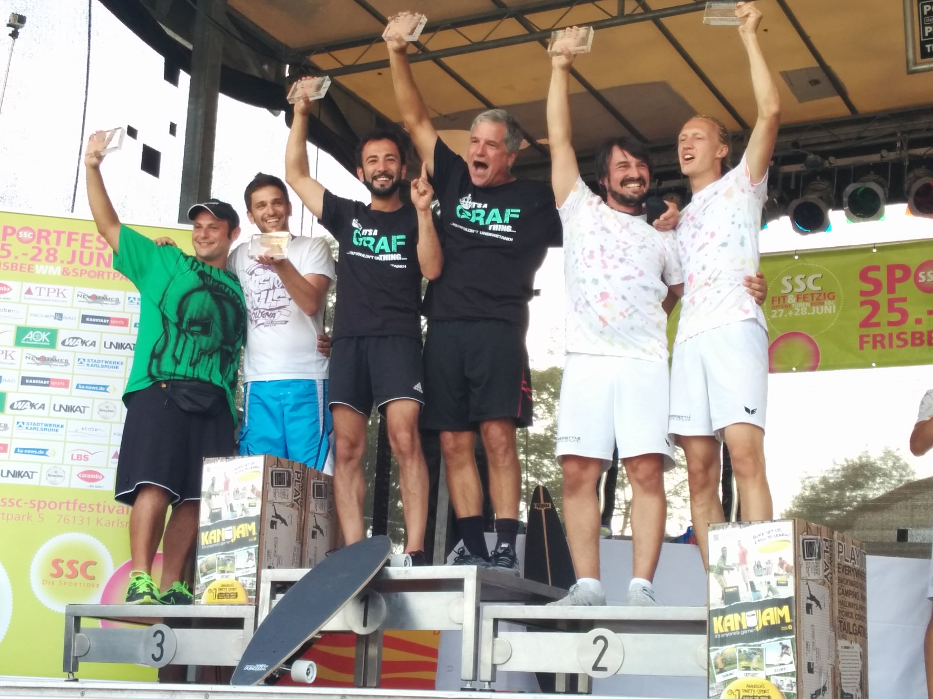
FPA Board Meeting: August 15, 2015 .

- Attending: Z (310.2667190), Bethany (414.3151660) ; Lori, Brian, Tita, Freddy (via Hangouts)
- Absent: Jakub Kostel, Jens

AGENDA:

- Recent appointment of Jakub Kostel as Member at Large to assist with website and social media with Brian Boate.
  - Lori’s Discussions with Fabio Sanna, Mystique (design of FPA), Emmanuel Faustini (Zanardi) re: upcoming Board positions (see below).
  - All of the above folks will either be nominated for elected position and/or working as consultant for the FPA. Fabio sounds interested in Educ Director position, Zanardi interested in Comp Director position, Mystique wishes to be a design consultant for FPA (and not attend lots of meetings, but work in consulting capacity).

- Directors’ updates:
  - Treasurer Report/update (Bethany): Need to stop spending FPA funds b/c of the website work is draining our savings.
    - We need new volunteers: anyone with Wordpress background and cannot use outside developer.
    - Plus Brad has asked for $3500 for the FPAW 2016: it was confirmed. To be sent $1500 the FPA sponsorship first; the $1000 is after trophies have been purchased; $1000 for prize money nearer to the dates of the tournament.
      - Authorized by the FPA Board to send $1500 to Brad for sponsorship.
    - We need to figure out some fund-raising ideas for the FPA. Possible raising of membership rates. Possible membership drive? Automatic membership renewal? Special meeting to be set up.
  - Competition Director (Freddy):
    - FPAW 2015 feedback, comments, debrief; time for more accolades for such a successful event
      - Whole event was successful; great feedback from SSC, sponsors, competitors; may be a new level of organizing tournaments – to have affiliated with a sports club. Roger M. helped as Div Director.
    - EFO/AFO Bids: any takers yet?
      - EFO: None.
      - AFO: Maybe
    - EF & AF: Open vs. Closed; time to discuss how this has gone and if changes are needed; future survey to the FPA members? Feedback about Open vs. Closed is that folks don’t want to run a tournament that’s closed. Freddy wants to add to the survey that maybe the EFO/AFO are run every other year.
    - 2017 FPAW location: Bibione, Italy ; probably going to be a beach wind, so need to clarify the venue and if there are limitations for having an FPAW on sand vs. grass. (FPAWs on the beach have used ‘red carpet’ before)
    - FPAW 2016 updates: fields, conversations with Brad Keller (Lori), follow-up from recent email exchange
    - 2015 WFDF World Freestyle event update (Lori): 22 open div, 4 women’s div, 3 junior div; full FPA judging system was used by WFDF tournament directors, specifically Thomas Olsen (Freestyle Director for this year’s WFDF)
    - 2015 AFC update (Lori/Bethany): mixed pairs (9 teams) deepest pool of tournament; things went well, although very small numbers of competitors. Ryan’s system was used and results were announced and posted fairly quickly. Training and practice session was provided to all competitors for an hour before competition began (which also went well). Jake G. and Lisa H. co-directed and it was a successful event.
    - Judging system update (Conversations with Flo & Ryan; Lori): Lori spoke with Flo after FPAW in Karlsruhe and clarified some of the miscommunication re: the electronic judging systems; Flo has some excellent ideas about eventually creating a large data base for all TDs to access for rankings and creation of pools – with possible blending of the automatic inputting of scores and calculations; agreed that having flexibility for tournaments to use whichever system fits for the tournament venue makes sense; he didn’t realize that the FPA Board hadn’t committed to officially recognizing his system only occurred in Jan 2015; Lori also conversed with Ryan about how his automated entry process was going and how to better integrate with Flo’s excel-based calculation of results, especially after next year.
  - Education Director (Tita):
    - Spread the Jam/Educational activities shared.
  - Membership Director (Jens): deferred since Jens was not at the meeting.
    - Updates to membership numbers
    - Conversations with Bill Wright?
  - Website Update (Brian):
    - Bugs fixed? Working on it.
    - Traffic to website going okay?
    - Process of blogging, posting, updating information
      - Website@freestyledisc.org is the email to use for any website-related issues that come up.
- Freestyle, WFDF membership, and the Int’l Olympic Committee’s recognition of WFDF in Kuala Lumpur two weeks ago.
  - What this means for freestyle’s future and how can we maximize this? This is a huge historical time for all disc sports, including Freestyle. We should be proactive with WFDF to further promote freestyle events in international sporting events, especially over the next few years.
- Disc Design contest announcement: Who willing to post this in 2.5 weeks? Tita agreed to do this. Z will assist.
- Upcoming elections for vacant FPA Board positions + positions needing to be back on three year cycles. Below is Lori’s spreadsheet that helps (hopefully) to indicate which positions should be elected in which years. Because of the past changes in Board personnel, additional positions will need to be elected for shorter terms in order to get us back on the right rhythm for the full 3 year cycles.
FPA Director Positions: Election Cycles and Terms of Office |  | 3 yr. term ends Dec of: | Voted in Election held Nov: | Term starts January of: | Who should be up for election?

Comp Dir | Educ Dir | Market Dir | Treas | Exec Dir | 2015 | 2012 | 2013 | Lori
Comp Dir | Educ Dir | Market Dir | Treas | Exec Dir | 2016 | 2013 | 2014 | Freddy/Tita
Comp Dir | Educ Dir | Market Dir | Treas | Exec Dir | 2017 | 2014 | 2015 | (Vacant), Bethany
Comp Dir | Educ Dir | Market Dir | Treas | Exec Dir | 2018 | 2015 | 2016 | ED

For 2015 elections only, the following positions will need to be on the ballot:
  - Executive Director (for 3 years)
  - Competition Director (for 2 years)
  - Education Director (for 2 years)
  - Treasurer (for 1 year)
  - Marketing Director (for 1 year)
  - Call for nominations process: via website and jammers listserv emails.
  - Voting process – use Survey Monkey? Possible to link through FPA website? We will discuss this during our next meeting, since elections will occur in November.
- FPA Hall of Fame: status update (Z): Maybe the induction can occur at NYC FPAW. With the website now functioning, we can use this to promote the inductees, their information, and possibly get this to be part of next year’s FPAW.

Next meeting: _____________________ (Doodle poll)

